**Easter Services 2025**

**Anglican Parish of Wingham**

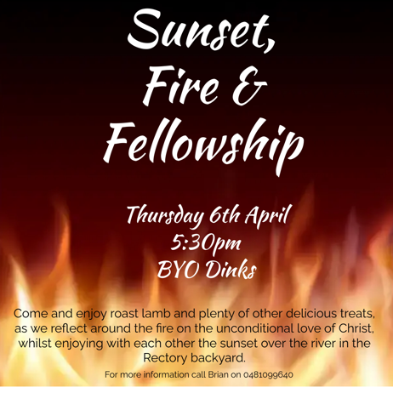 **Maundy Thursday**

Sunset Fire & Fellowship at 5.30pm

@ the rectory Wingham.

*Roast Lamb etc on rolls with gravy, sitting around a camp fire in the Rectory backyard overlooking the river at sunset.*

*BYO Drinks and a dessert to share.*

**Good Friday**

**10.00am** Combined Service @ St Johns Taree.

*The bus will run from Wingham at 9.00am.*

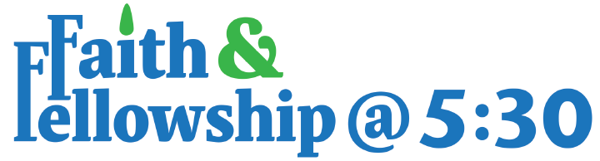

**5.30pm** Journey from

Good Friday to Easter Sunday

@ St Matthews.

*Followed by Hot Cross buns together.*

**Easter Sunday**

**10.00am** St Matthews - Holy Communion followed by morning tea.

**1.00pm** St Marks Marlee – Easter Picnic Lunch - Bring and share.



**2.30pm** St Marks Marlee - Holy Communion followed by Afternoon Tea.

For more information

Contact Brian Ford 0481 099640.